Contributor: David Fernando Cortés Saavedra

**Torres-García, Joaquín**

Born: 1874 – Montevideo; Died: 1949 – Montevideo.

Father of *Universalismo Constructivo* and founder of the *Asociación de Arte Constructivo* and the *Taller Torres García* in Montevideo, Torres-García was the most important modern Uruguayan artist of his time and a direct precursor to concrete art in Latin America. Based on his experiences in Europe with artist Antoni Gaudí, the group *De Stijl,* and the artists gathered around the magazine *Circle et Carré,* Torres-García elaborated the premises of his *Universalismo Constructivo,* which he would concretize upon his return to Montevideo in 1934*. Universalismo Constructivo* is best defined as Torres García’s constructivist work in which schematic figurative elements are held by a grid pattern regulated by the golden section and a pinwheel structure. It was considered by North American theorist Clement Greenberg as an example of *all over* painting.

At age 17 Torres-García left the Uruguayan capital with his family embarking to Spain (Barcelona) where he studied at the Academy of Fine Arts and the *Baixas* Academy before becoming a member of the *Cercle Artístic de Sant Lluc*. The artist participated in the construction of the stain glasses of *La Sagrada Família* basilica under the direction of Antoni Gaudí; the decoration of the Uruguayan Pavilion in the World exhibition taking place in Bruxels in 1910 and the mural paintings of the *Saló de Sant Jordi* of the Municipal Palace of Barcelona from 1912 to 1917. During this period Torres García contributed briefly to the formal development of *noucentism* in Barcelona, but quickly moved beyond it, as he strived for simplification, flatness and modernity. Between 1918 and 1926 moving between New York, Italy and the south of France, Torres-García devoted himself to the fabrication of modular wooden toys the aimed at developing in children a new sense of reality and constructive capacities

From 1926 until his return to Montevideo in 1934, Torres-García joined the international community of Paris based artists influenced by Cubism, Russian Constructivism and the art of the Dutch painters of *De Stijl*. In this context and transposing solutions found on his wood cuts to the canvas, Torres-García developed a rustic constructivist style and a polyphonic grid structure preluding his *Universalismo Constructivo*. After an initial contact with the Dutch painter Theo van Doesburg, Torres-García founded the magazine *Circle et Carré* along with **Michel Seuphor** and the collaboration from figures as **Georges Vantongerloo**, **Piet Mondrian**, **Hans Arp** and **Van Rees** from which only three issues were published in 1930.

Discouraged by the situation of the art market in Europe, Torres-García moved to Montevideo in 1934 where he founded the ***Asociación de Arte Constructivo* (AAC)** profiting from his links with important organs of cultural diffusion such as the *Ateneo de Montevideo*, the *Universidad de la República* and the *Escuela Taller de Artes Plásticas*. In 1938 he engraved his *Monumento Cósmico Constructivo*, synthetizing the plastic, metaphysic and pre-Columbian premises of *Universalismo Constructivo* through the hierarchical disposition of emotional and rational symbols engraved on the surface of the pink granite wall. Torres-García wrote dozens of books on art and philosophy and was a tireless educator leaving a legacy of more than 500 lectures behind him. The painting workshop which carried his name (*Taller Torres García*) preserved his teachings through a vast production of painting, sculpture, ceramics, wood and iron reliefs, decorative objects, textiles and murals.

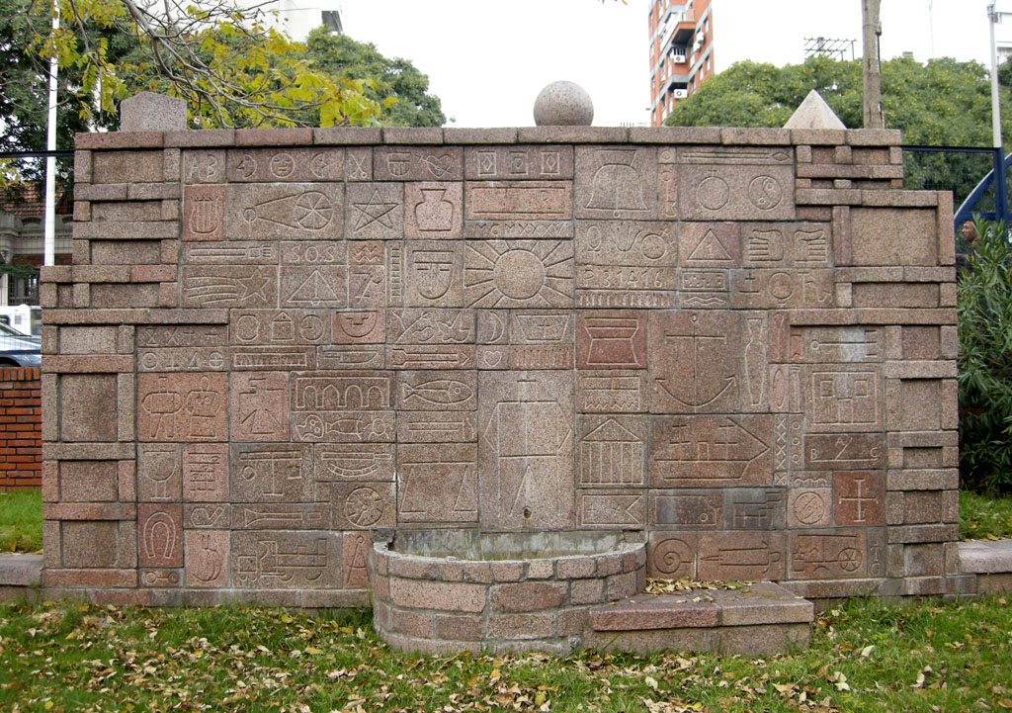

**Joaquín Torres-García.** *Monumento Cósmico*. (1938). Pink granite. Location: Park J.E. Rodó. Montevideo.

http://3.bp.blogspot.com/-T7p_twSGAaw/Tda1SeH_LFI/AAAAAAAAAT8/JJrBLK2Ev6g/s1600/parque17.jpg

Joaquín Torres-García. *Monumento Cósmico*. (1938). Pink granite. Location: Park J.E. Rodó. Montevideo.

http://3.bp.blogspot.com/-T7p_twSGAaw/Tda1SeH_LFI/AAAAAAAAAT8/JJrBLK2Ev6g/s1600/parque17.jpg

**References and further reading:**

Cruz, Pedro. 1994. *Torres García and “Cercle et Carré”: The Creation of Constructive Universalism* *; Paris 1927 - 1932*. Lund: Hansson & Kotte.

Gradowczyk, Mario Horacio. 2007. *Torres-García: Utopía Y Transgresión*. Montevideo: Museo Torres García.

Greenberg, Clement. 1961. *Art and Culture; Critical Essays*. Boston: Beacon Press.

Torres-García, Joaquín, Susan Ferleger Brades, Arts Council of Great Britain, and Arts Council of Great Britain. 1985. *Torres-Garcia: Grid-Pattern-Sign / Paris-Montevideo 1924-1944*. London.: Arts Council of Great Britain.

Torres-García Museum Montevideo. http://www.torresgarcia.org.uy/

**List of Works**

*Lo temporal no es más que un símbolo*. (1916. Fresco)

*Locomotora* (1919. Wooden toy)

*Auto de Carreras* (1921. Watercolor)

*Constructivo con Maderas* (1929. Carved wood)

*Planar painting wiht boat* (1929. Oil on canvas)

*Constructivo Ph5* (1931. Oil on canvas)

*Monumento Cósmico.* (1938. Pink granite)

*Stalin* (1939. Oil on canvas)

*Pax in Lucem* (1944. Wall painting)